HAUNTED HOTEL
Would you like to spend few nights with the scariest horror characters? Yes? Then The Haunted Hotel is the right choice for you.
Hotel is located in Derry (fictional town that has served as the setting for a number of Stephen King's novels, novellas, and short stories).The hotel has got 100 rooms. One more spooky that the other. Every room is decorated according to a different horror movie. For example: If you are a fan of the horror ANNABELLE, your room will be full of dolls and self-bending chairs. If you are a fan of IT MOVIE, then your room will be full of red bloody balloons. When you´re in this room, you must be careful, because you never know when the killing clown Pennywise will try to kill you. BUT DON´T WORRY, most people survived. Most rooms have: one creaking bed or double bed, WC, shower, fireplace, wardrobe, old TV and also private sauna.
And what about the elevator? Haunted hotel has got the most interesting elevator in the world. It is better to take protective clothes into the elevator, because you never know when the fake blood will spray on you. Sometimes the elevator stops for a few hours and sometimes the elevator goes down sharply.
Food is another unusual thing. Morning buffet is from 5:00 a.m.-9:00 a.m. You can eat pancakes with spider eggs, zombie-bacon, bloody muffins, vampire omelette, but not everyone is a fan of this food and this is why our hotel also serves scrambled eggs, bacon, sausages, black pudding, baked beans, tomatoes and mushrooms. Interesting thing is, that there is no dinner or lunch. Visitors have the big feast at WITCH HOUR (midnight).Flying tables are full of exotic fascinating food, so I promise that you won´t be hungry.
What can you do in the Haunted Hotel? You can watch horror movies in cinema, jump into to bloody bath, there´s also THE STEPHEN KING´S LIBRARY, a theatre (only The Phantom of the Opera and the musical Carrie is played here). Also you can try the dangerous water slide that ends in the bloody lagoon full of vampire´s teeth and dead alligators. Or why not football? Football here is a bit different, because the killing ball is trying to eat your foot and all you have to do is just kill the ball, before the ball eats your foot.
From the hotel you can see copies of traditional horror houses.
What about the outer look? The hotel is 200 metres long and 300 metres wide and 800 metres high (almost as Burj Khalifa).The entire hotel is built from old wood, so you must be careful, because you never know when and where it bursts. In some rooms old moving trees go through the hotel.
The best season to visit this hotel is autumn, because there´s a big Halloween ball.
One night costs from 330 €.
So, would you like to spend a few nights in this absolutely special hotel?

Kitchen 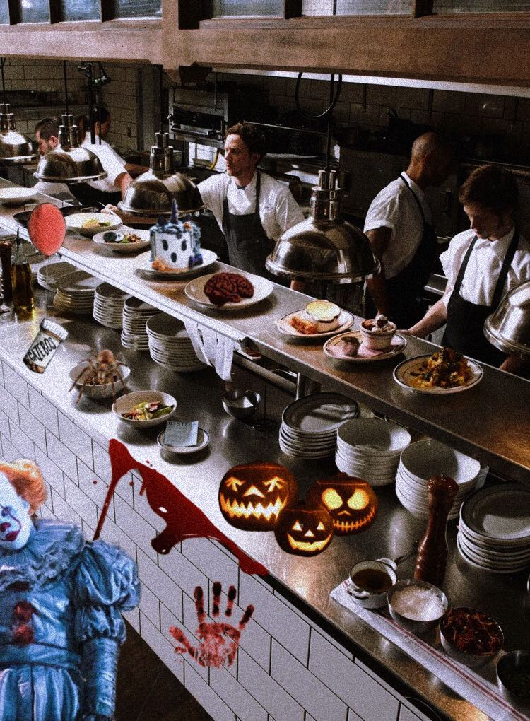
(modified photo from Pinterest)

The elevator and the receptionist Bob
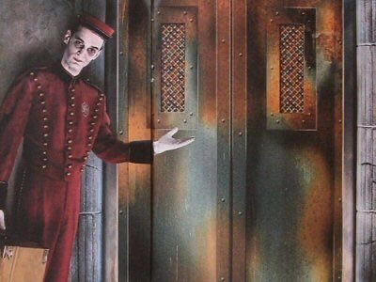
(photos from Pinterest)
